Entertainment: Books

Kogos: Little Current writer's gripping narrative
By Bonnie Kogos, Special to Sudbury Star
Saturday, June 30, 2018 11:47:02 EDT AM
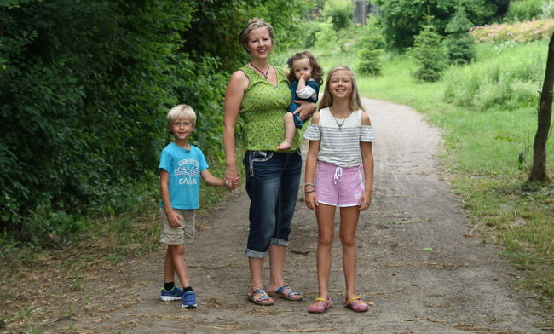
Supplied photo Debut novelist Jennifer Farquhar and her children enjoying a quiet moment on the trail behind their home in Kitchener. She’ll be in Little Current on Canada Day, and July 4 on The William Ramsey in Sudbury.
I'm dishing with publisher Heather Campbell of Latitude 46, based in Sudbury, who said, "Bonnie, you were there when Laura Stradiotto, my co-publisher and I began in 2015. We'll have published 15 books by the end of this year."
"I'm proud of what you and Laura have accomplished. How has it been?"
"Challenging," Heather answered candidly. "Laura and I absolutely love what we do, and are excited about the authors we're able to publish. Latitude 46 receives many submissions yearly and we're grateful. Because there's always a gem and we're always looking."
I knew it well, telling Heather I grew up in a publishing family; not only did I type, answer phones, edit, proof galleys, I swept our office floor, packed books, and worked at sales conventions. I was glad to hear Heather laugh.
"Bonnie, we have a wonderful event in Sudbury this Wednesday, July 4, at 7 p.m., aboard The William Ramsey, docked near Science North. Latitude 46 Publishing is offering a delightful literary evening on the lake in Sudbury.
"Our cruise is over an hour, featuring our author, Jennifer Farquhar, and her debut novel, titled Watermark. She'll read from her book, and sign copies for sale. It's $10 per person, with a cash bar. For a ticket, go to www.eventbrite.ca.
"We're also thrilled about the Launch Party on Canada Day in Little Current," Heather said. "Hosted by The Manitoulin Expositor to celebrate Jennifer's debut."
Jennifer grew up in Little Current, where she attended the local school. As a youngster, she entered poetry and writing contests that she knew about, and often won them. As a teenager, she entered a short story contest held by The Manitoulin Expositor and won first prize. She's come full circle.
I read Watermark, reading it quickly, loving Jennifer's gripping narrative; the full scope of construction in telling of young Mina's return to the island where she grew up and the way in which Mina is forced to uncover and deal with a tragedy on the island from her past. Adding to this, my deep respect for Manitoulin and First Nations stories and descriptions.
Happily, we met. "Jennifer, how did you choose this title?"
"I like the title to be something poetic, so will play around with words related to the theme, until the perfect title surfaces.
"I began to write Watermark the day of my 40th birthday. It was my gift to myself to write the novel I've always wanted to write. Having tinkered with short stories for years, it was time to push myself further.
"It took five months to write the first draft and nine months to revise, revise, and revise. You know how it is, getting ready to submit to agents.
"Eventually, I was signed on by well known literary agent Samantha Haywood in Toronto. Then we had another year of revision before she submitted Watermark to publishers. I was thrilled when Heather and Laura chose to acquire it."
Jennifer attended McGill University, earning a B.A. in humanities and women's studies. She followed her studies attending McMasters University, in midwifery, and realized that it was too stressful a lifestyle. She told me, "Now, Bonnie, it's easier to get up in the middle of the night when it's your own children."
In 2004, she met Thanos in Hamilton, an emergency doctor practising in southern Ontario. They married and she went back to school to earn her bachelor of education from Laurier University in Waterloo.
"Writing took a back seat for almost a decade. After Thanos and I married, we had our children, I went back to school for my teaching degree," she said. "While life was full and busy, I yearned for my creative outlet. I had to carve out writing time for myself. Or it was never going to happen."
"Good for us. How did you do this?"
"Since both my children were in school, and I was working as a teacher half-time, I wrote hungry, in the morning, and committed to a daily quota of 1,000 words minimum. Before I began the novel, I mapped out the main plot, the subplot, flushed out the characters, and planned the character arc.
"It was a bare bones skeleton of a plot, and I fleshed out more by putting pen to paper each day. By the time I got to the end of the story, it was quite different from what I had originally imagined."
"Jennifer, my writing teachers have told me to write hungry, as well. It works," I said, getting hungry. "Who has influenced you on your creative journey?"
"Easy. My Dad. When I was growing up, he thrived on being a jack-of-all-trades entertainer. He wrote songs and performed them for community events and the local TV station. He wrote plays for the church youth group, and painted and built the backdrops. He created huge, fantastic bulletin boards for my mom's classroom walls every summer. Now he puts on solo guitar shows at The Manor.
"The treasure I received from him: the idea that your own creativity can be a wellspring of weird, wonderful stuff. Trust it. I owe so much to both my parents for all of their support and encouragement."
"What's the most surprising thing you learned during the process of writing and editing Watermark?"
"Most surprising is the writerly equivalent of the movie Field of Dreams. I learned if I show up to the page each day, willing to descend into that deep, creative space necessary for writing fiction, the story will slowly emerge," Jennifer said. "If you write it, it will come."
To celebrate Canada Day, Jennifer will share her thoughts and stories with us in Little Current. You're cordially invited to stop by The Expositor Office at 1:30 to say hello.
-- Our Bonnie is happy to be here in Sudbury and on Manitoulin on July 1 in Little Current. She keeps meeting people and discovering stories that delight us. Find her at BonnieKogos@gmail.com.

